**Evaluating Antennas For LEO Satellites**

By Terry Osborne ZL2BAC

*The release of the EZNEC Pro [1] antenna modelling program has given us an excellent tool to evaluate various antennas and see how well they match the requirements for LEO Satellites.*

In this paper I have included the Vertical Radiation Pattern results of some popular antennas and have tabulated the results on a spreadsheet available on GitHub [2]. All the antennas are modelled at 3 Meters above a real ground from EZNEC Pro.

The ideal antenna for LEO satellites should have maximum gain at the horizon and a smooth transition falling to about 10 dB minimum overhead. This is well described in the AMSAT Journal March 1990 [3].

To confirm this, I found an on line slant range calculator [4] to calculate the range for various elevations and various satellites. From these figures, I calculated the Free Space Path Loss using the well known formula:

PL = 32.4 + 20*LOG(Range) +20*LOG(Frequency) where Range is in KM and Frequency in MHz.

I then calculated the difference in path loss from 0 degrees to 90 degrees elevation (Gain at Elevation). See Table 1 (screen shot of spreadsheet) for an RS44 example.

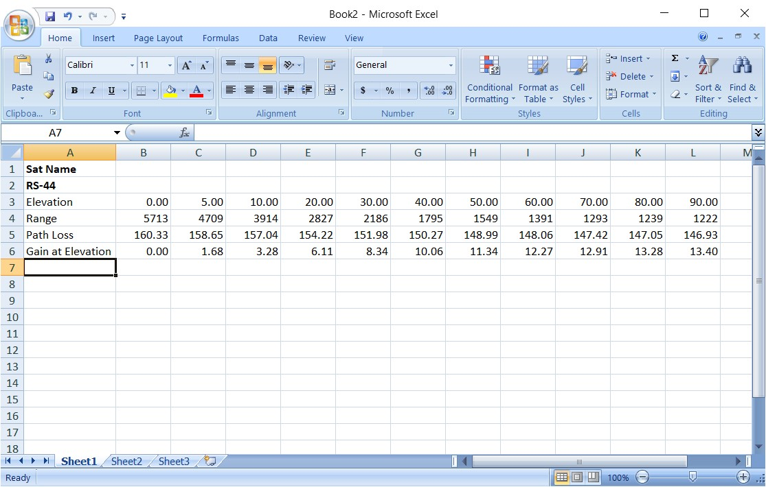

The importance of coverage overhead is often exaggerated since the satellites spend very little time at high elevation angles. For an XW2A example, see Figure 1 from Leovis and Note 1.

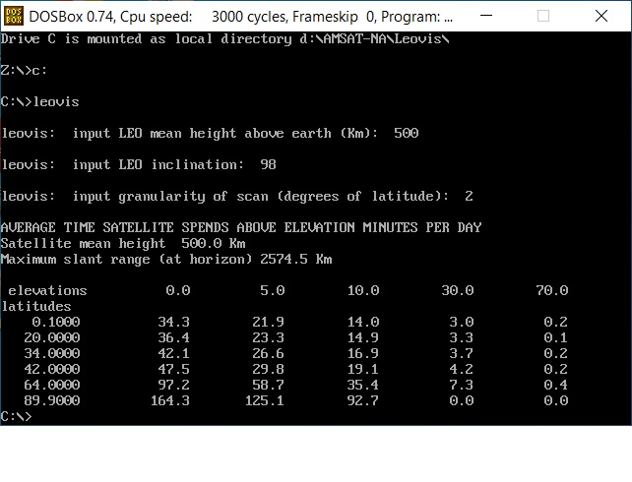

**Antenna Evaluation:**

Radiation at 0 degrees elevation is not possible due to ground absorption and even NASA considers an elevation of 5 degrees being the minimum for a ground station.

1. 2 M Quarter wave Ground plane. See Figure 2 (2M QuarterWaveGP).

This is the simplest antenna and gives an almost acceptable radiation pattern. The overall gain is low but this can be compensated by the installation of a low noise preamp. Note that the polarization of the received signal at low elevations is normally vertical as confirmed by tests on AO-91 using a hand held yagi. Other vertical antennas give similar results but increasing the gain at lower angles results in gain reduction at higher elevation angles.

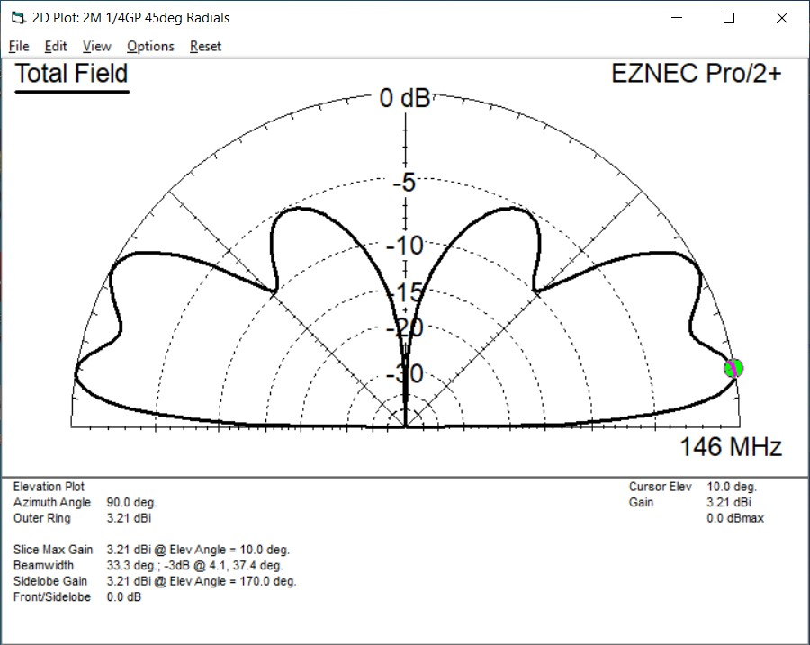

1. **Turnstiles:**

All variations of Turnstiles give similar results and I have included the 2M Eggbeater (M2 version). See: Figure 3 (M2 Eggbeater 2M).

This popular antenna is horizontally polarized at low angles and circular at higher angles. Note that there is a deep null at about 17 degrees elevation. This is due to ground reflection. The angle and depth of the null varies with antenna height and is responsible for the varying results that are reported by users of this antenna. It will give good results above 20 degrees elevation.

The best results with a minimum null are from an eggbeater with square loops.

See: GitHub [2].

Note that trying to increase the gain at low elevations results in a deeper null just above the angle of maximum gain.

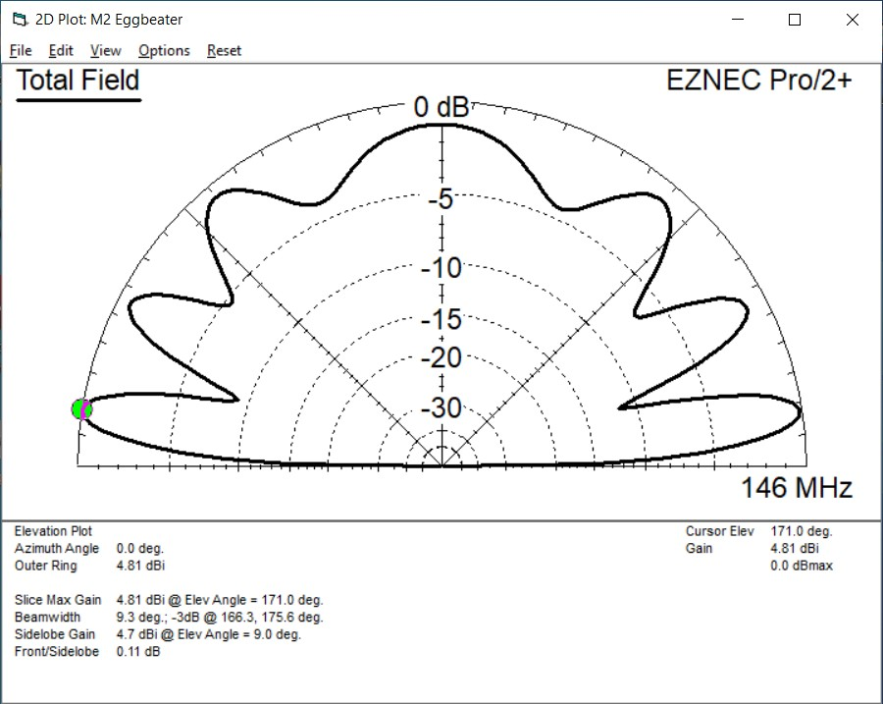

1. **Lindenblad**. See: Figure 4. (2M Lindenblad).

This is probably the best of the Omni directional antennas. It is the only one that is circularly polarised over the whole pattern. It does have a null at higher elevation angles but this may not be a problem as outlined above.

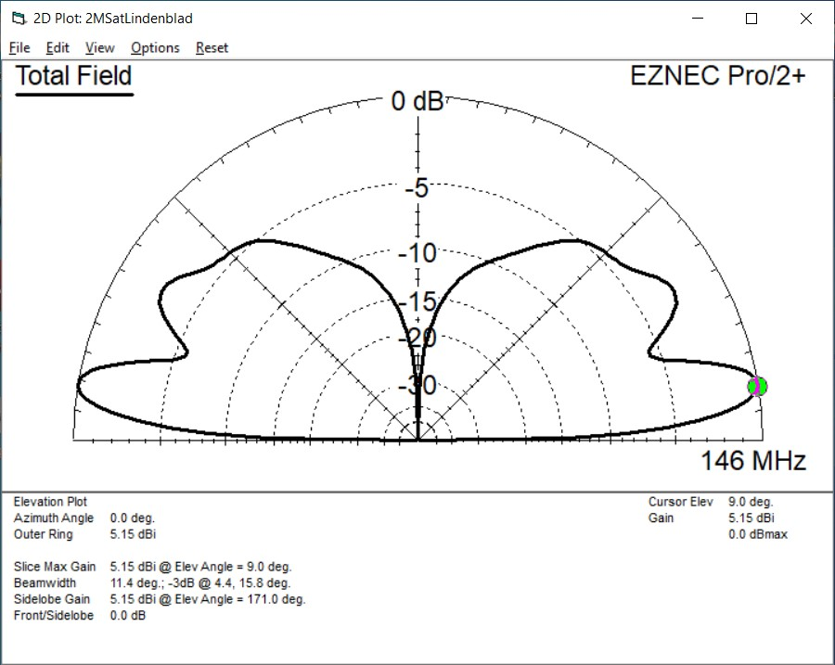

1. 2M Moxon Loop Turnstile.

This antenna was originally described by L.B. Cebik, W4RNL (SK) and the details can be found in QST August 2001. This antenna has a minimal earth reflection null due to the low back lobe of the Moxon Loop design. It has good gain characteristics and should perform better than the Egg Beater antennas. See: GitHub [2].

1. **2M Quadrifila Helix.**

This antenna proved difficult to model but I was able to come up with a model that used 4 straight wires for each helix. This antenna looks to be quite effective with maximum gain at higher angles. See: GitHub [2].

1. **2M 3 Element Yagi.** Figure 5 (3El Yagi @ 25Deg Elev) .

This antenna has the highest gain of the 2M antennas modelled and is typical of the Arrow and similar antennas. This one is modelled at 25 degrees elevation which is how it would be used in a fixed station with a small azimuth rotator. The high gain and good pattern back up the results observed by operators using hand held antennas and portable stations.

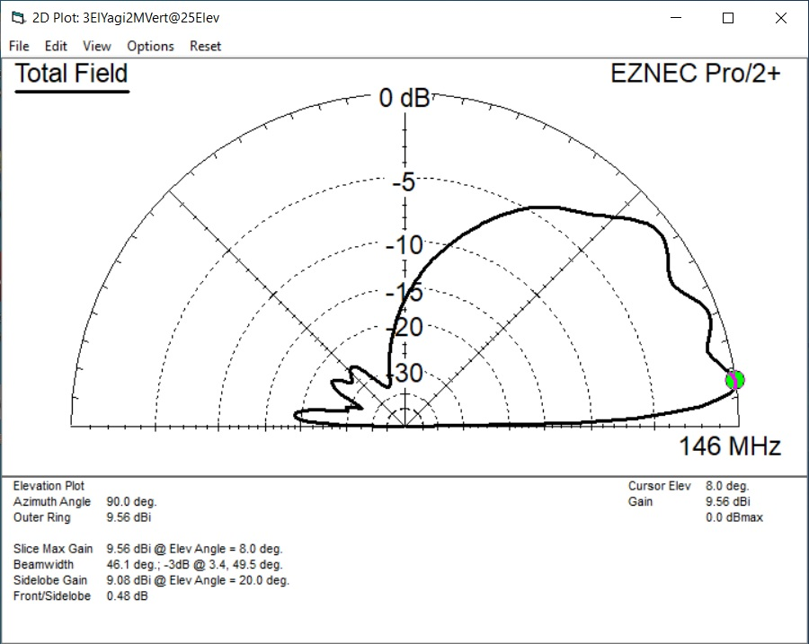

1. **70 CM Eggbeater (M2).** At 70 CMs a problem of multiple ground reflections occurs and you have an antenna that will suffer from fading and loss of signal.

See: Figure 6 (70CM M2 Eggbeater).

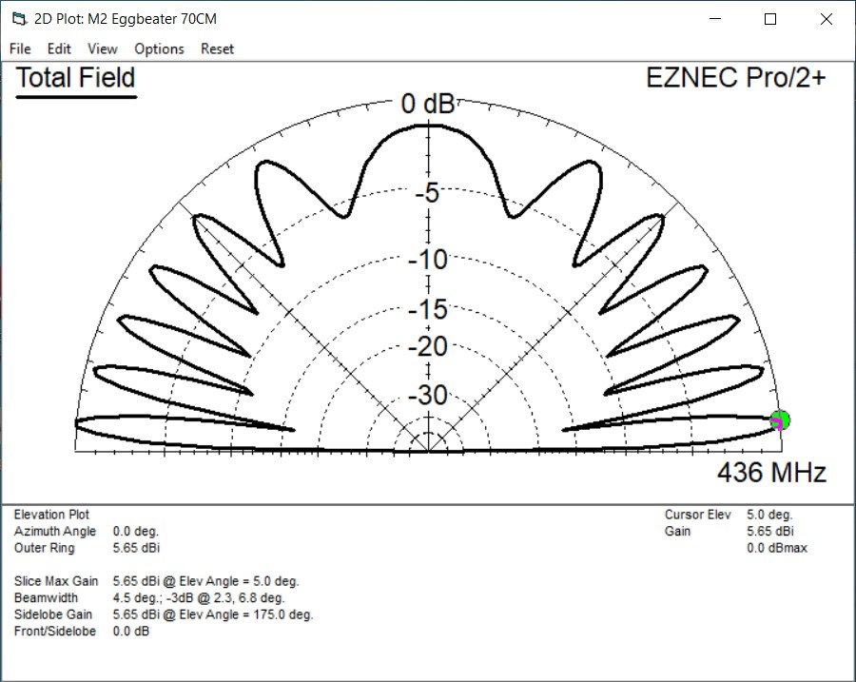

1. **70 CM 7 Element Yagi.** This worksmuch better than the eggbeater. See Figure 7 (70CM 7El Yagi ).

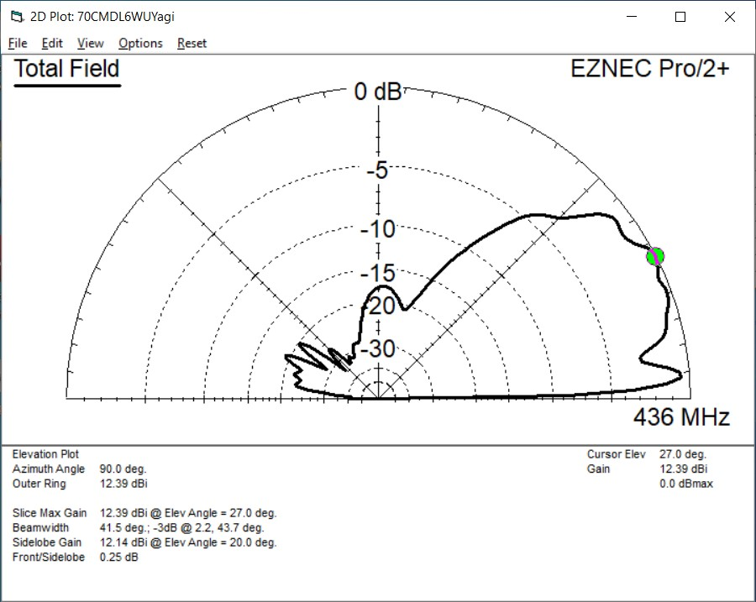

I have also modelled several antenna designs that are not included here. The plots of these are in GitHub [2].

I have also made a spreadsheet to compare the performance of the popular antennas on 5 typical satellites. See: Results (Results screenshot of spreadsheet) and GitHub [2].

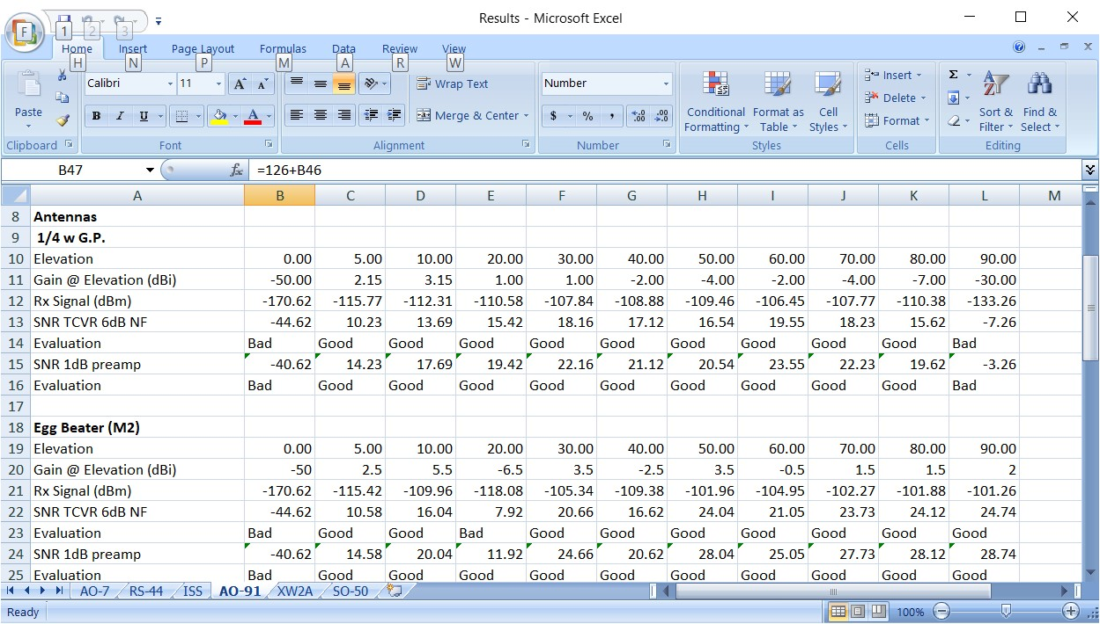

The satellites are: AO-7, RS-44, ISS Cross band repeater, AO-91 and XW2A.

Only downlinks have been considered because the ground station can make up for any extra losses by increasing their Transmitter power.

The EIRP values for each satellite are taken from the published data as far as possible.

Receiver Noise floors are based on calculations and are: -138dBm for SSB with a 6dB noise figure, -145dBm for SSB with a 1dB noise figure preamp, -126dBm for FM with a 6dB noise figure, and -130dBm for FM with a 1dB noise figure preamp.

Feeder loss has not been considered.

**Conclusions:**

Satellites with a 2M downlink can be worked with most antennas. Even a simple ¼ wave ground plane will give surprisingly good results. A 1dB Noise figure or better preamp would be useful but not essential.

Eggbeaters and other types of Turnstiles will give varying results at low angles due to ground reflections but work well above 20 degrees elevation.

Similar comments apply to the QFH antenna.

The best omnidirectional antenna is the Lindenblad. The overhead null should not be a problem.

The best antenna for 2M is a small yagi. The 3 element version modelled is far better than any of the other antennas. You can use vertical polarization, a fixed elevation of 25 degrees and an azimuth rotator on a home station and obtain good results. Circular polarization and an elevation rotator are probably overkill.

For a 70CM downlinks, the ISS can be worked with most antennas but for RS44, SO-50 and the upcoming Golf satellites, a yagi will be required. Again vertical polarization, a fixed elevation and an azimuth rotator will give good results.

Note 1: Figure 1 was produced with an old DOS program, “Leovis” by Duncan Courtenay N5BF. Many years ago, Courtney Duncan N5BF wrote a simple program to predict the time spent at various elevation angles. This program is available in the AMSAT archives as “Leovis” (https://www.amsat.org/amsat/ftp/software/PC/tracking/leovis.zip). This is an old DOS program and would not run on my Windows 10 box. Duncan was kind enough to include the source code in the distribution and I was able to re-compile and run it.

**References:**

[1]: https://www.eznec.com/

[2]: <https://github.com/TerryOz/Evaluating-LEO-Antennas>

[3]: Amsat Journal Vol3 No 1 March 1990: Antennas for Microsat Ground Stations by Dick Janson WD4FAB.

[4]: <https://www.vcalc.com/wiki/KurtHeckman/Slant+Range>